Normal Emergency
PRINT - FILL UP – SCAN - SEND
1
2 0 1
Your Tel

Dt. of Submission of Horoscope:
2 0
1
Your Tel

Dt. of Receive of Horoscope:
Name: (Mr./Mrs./Miss)

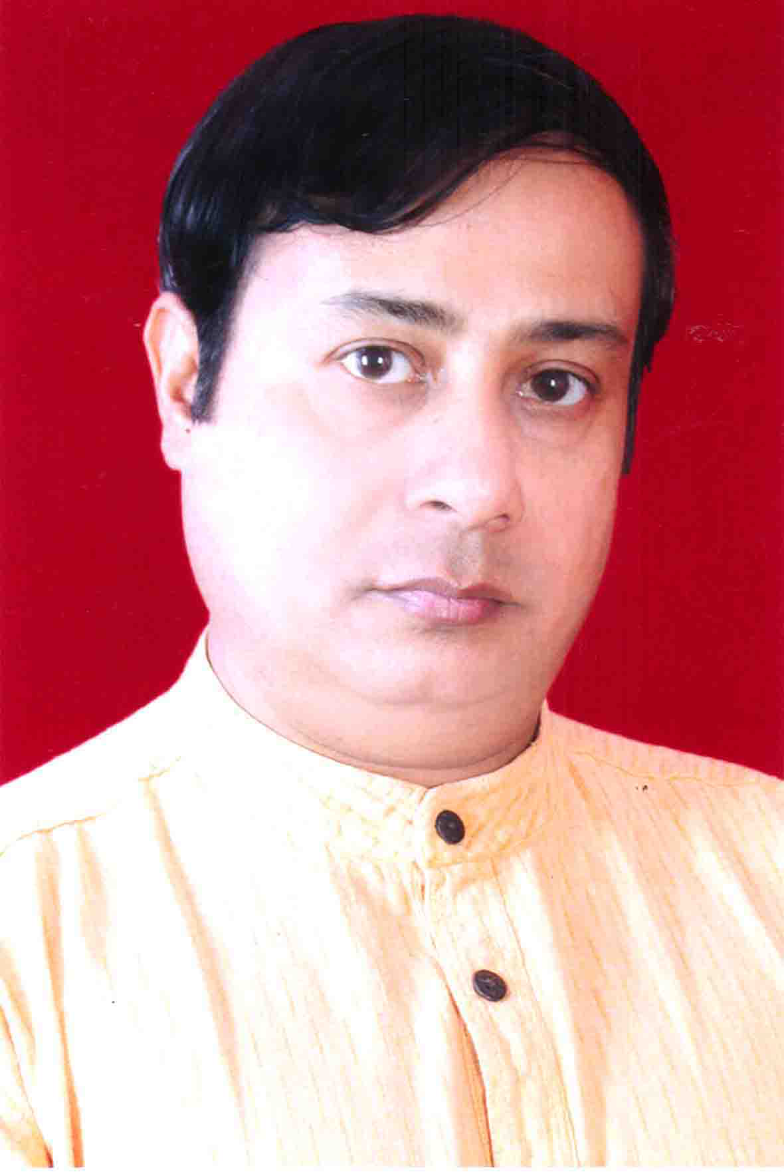
Birth Date: (If the birth is between 12 A.M. to

Birth Time: Day Night A.M. P.M.
Birth Place: Block:
Rashi: Police Stn: District:
Nakshetra: Sub-Division: Post Office:
Lagna:
Palm Leaf Horoscope Khata Horoscope Photocopy attached Verbal
Weekday: /
QUESTIONS
QUESTIONS

1) Marriage 2) Marital Life 3) Divorce 4) Child 5) Property

6) Legal Case 7) Promotion 8) Diseases 9) Health 10) Foreign tour

11) Higher Study 12) Present Education & Result 13) Job 14) Change of Job

15) Suitable Career & Business 16) New name of the child

17) Financial condition 18) Present Career & Business

PAST EVENTS
PAST EVENTS
Marriage: (Month & Year)
Vehicle-(1): (Month & Year) Month & Year-(2)
Construction of house Starting:(Month & Year)
Property-(1): (Month & Year) Property-(2): (Month & Year)
What are you doing now?

1st Child: (Month & Year) 2nd Child:(Month & Year)
Fracture: (Month & Year) Month & Year
Surgery :( Month & Year) Month & Year
Legal Case :( Month & Year) Month & Year
Loan :( Month & Year) Month & Year
Suspension in Job or loss in Business:( Month & Year)
Promotion:( Month & Year) 2nd (Month & Year)
New Business Start:( Month & Year)
Higher Study:( Month & Year)
Death of Father:( Month & Year) Death of Mother:( Month & Year)
1st Job or Business:(Month & Year) Diseases: (Month & Year)

Signature- SBI A/c No.10066738345.
IFS Code: SBIN0007047.

